Little SPARK: Simple Play Adaptations to Reference for Kids

Communication Board Protector
Description: | Image:
Add durability to paper communication boards by inserting them into this plastic sleeve. Great for the communicator on the go, this plastic protector fits one 8.5” × 11” sheet of paper and features pockets on both sides. | 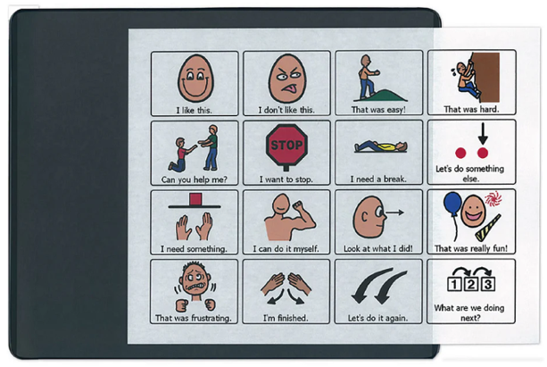

Who Might Benefit?
Those who are need symbol support to express or understand information, grip pages too tightly, and/or are engaged in messy activities.
Why Use?
Provides an opportunity to communicate on-the-go across partners and activities, using a variety of communication symbols.
Instructions for Use: | Adaptation Ideas:
Environmental Considerations  - Easily use in almost any environment because of the small size, weight, and easy transportability.  Positioning  - Use in most any position on a table top, placed on the floor, positioned on a slant board, or any position while providing at optimal viewing level and ensure its within reach of the child.  Basic Play/Use  - Introduce using added symbol/visual support pages to the child and explain what you are going to be using it for.  - Be consistent in the use of visuals.  - Make accessible to everyone supporting the child (e.g. have a specific area for keeping it) and make sure everyone knows where it is.  Extended Play/Use  - Model use of communication boards. | Build It Up  - Build up edges for easy gripping or to provide high contrast.  Simplify It  - Start with only a few photos or visual symbols on each page based on the child's ability to understand and select responses, adding more as needed.  Stabilize It  - Velcro to various surfaces in the environment as needed so it does not shift while the child is attempting to access it.  Add Sensory Cues  - Consider using high contrast visuals and/or contrasting background.  Alternative Uses  - Can be used for visual schedules and sequences.  DIY Alternatives  - Place communication pages in a sheet protector with a piece of thin cardboard backing between the front and back pages.  - Place communication pages in a gallon-sized ziplock bag. Insert a piece of thin cardboard backing between the front and back pages, trimming as needed, and zip closed.  - Use a one inch binder with a clear view cover to display communication pages. Additional communication pages can be stored inside. One inch spine offers a slight slant which may benefit viewing.  - Cut the covers off or 3 ring binders with clear view covers and insert communication pages.

